Section 5: Cleaning, Drying, and Curing
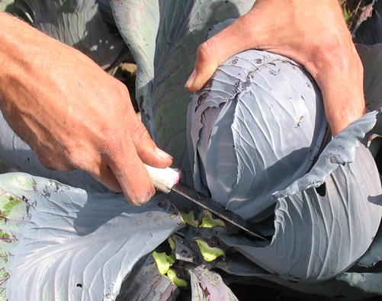
Pick It Clean — Keep It Clean: When cutting low-to-the-ground crops, like cabbage, cut above the mud splash/soil area. Keep the picking knife, hands, and harvest crate free of soil. You can harvest in muddy conditions and bring the cabbage out of the field clean, not needing to be washed. 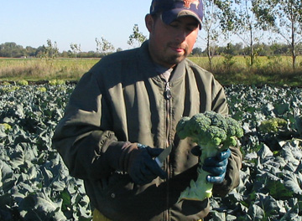
This broccoli won’t need to be washed. It’s already clean in the field, and Avel—a skilled harvester—takes care to keep it clean during harvest.
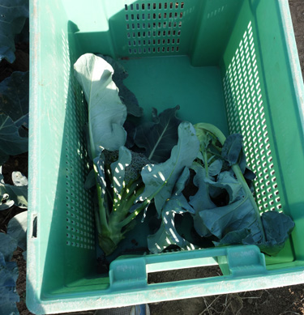

While cleaning, washing, rinsing, and sanitizing produce may appear to increase costs these steps enhance product quality and offer many crucial benefits including:
- Clean produce is more appealing to customers.
- Soil and particles that can promote spoilage are removed, helping to increase the product’s shelf life.
- Microorganisms responsible for causing food borne illnesses can be present in soil and spread by harvest and packing equipment, and handling. Cleaning can help eliminate or reduce them to a safe level.

First Steps Start In The Field
Use growing and harvest systems that minimize dirt on produce whenever possible.
- Straw and living and plastic mulches reduce ground contact and prevent soil from splashing onto fruits and vegetables.
- Windbreaks reduce dust.
- Avoid activities that will splash mud onto produce.
- Harvest in non-muddy conditions when possible.
- Keep hands free of soil and other contaminants during harvest and use clean and sanitized knives and harvest bins.
- When harvesting crops that are very dirty, such as roots or vegetables that rest on the ground, use a cloth or cotton gloves to wipe off the majority of dirt and leave it in the field.

When to Clean, Wash, Dry, And Cure
Many crops will need to be washed before cooling and storage, and some will be washed after storage. Some crops will not need to be washed or will be cleaned with a process that does not get them wet. Others should not be washed until they will be eaten and must be grown and harvested clean. Some crops need to be dried before packing, others are best packed wet, and some should be cured. This could all seem a bit confusing, but one thing is absolutely clear; all produce should be clean when it is sent to market.

All produce should be clean when it is sent to market. To be considered clean, produce should be visually free of dust, dirt, soil, and other debris.

Broccoli, cabbage, cauliflower, beans, peas, tomatoes and summer squash, are crops that can often be harvested clean and shipped without further cleaning if care is taken by the picker. However, if you can see visible dirt, dust, soil, or other debris—the produce needs to be cleaned. Avoiding unnecessary cleaning, saves not only labor and time; it moves the product more quickly to cooling, which is crucial for shelf life. Also some crops can be negatively affected by washing such as peas, beans, cabbage, and summer squash.

With the exception of storage onions, winter squash, it is generally recommended to wash produce that needs washing as soon as it leaves the field, and then move it quickly on to cooling and storage. It is generally recommended to wait until after storage to wash root crops, though some farmers prefer to wash them before storage. (See side bar for more information.) For crops such as baby greens and bunched greens, the cleaning and cooling process may happen simultaneously in the same process. Learning the correct process for each vegetable is important to maintain quality, minimize food safety hazards, and maximize shelf life.
Root Crops: Wash Or Don’t Wash Before Storage?
John Fischer-Merritt of Food Farm washes root crops before winter storage. He experimented by storing carrots through the winter both washed and unwashed. He found that the carrots that were washed before storage were beautiful all winter, and spoilage was not an issue. The way they were packed they didn’t get limp or dehydrated. The carrots that were stored dirty didn’t look clean after washing; the soil left stains on the carrot skins.
Food Farm now washes all of its root crops—carrots, beets, parsnips, rutabagas, and potatoes—in fall at harvest before storage.
Pallet sized wooden bins are lined with a giant plastic bag. On the bottom of the bag an inch and a half of dry peat moss is spread, on top of that a burlap sack is laid to keep the roots clean, and then the roots are packed to the top and the plastic bag is closed over them. The peat absorbs any excess moisture that comes off the roots and holds the humidity. John finds there is no need to control the humidity of the root cellar; the microclimate is perfect inside each bin.
Potatoes too are washed at harvest, and then packed in wooden bins with peat moss and a burlap sack beneath, but without the plastic bag.
The farm doesn’t have a heated pack house so not having to wash during the winter in the crowded root cellar is an additional bonus. He says, “It is so much easier to ship them now, already cleaned.”
The farm has a barrel washer now but for years John used a commercial dryer drum as a homemade barrel washer. As it turned slowly the roots were sprayed with a power washer.
Steve Pincus of Tipi Produce and his wife Beth put 100,000 pounds of roots into storage for the winter—unwashed. The roots are harvested into an unlined wooden bin right in the field. The filled bin is covered with a large plastic bag that goes all the way to the bottom. The bins are stacked the height of the cooler.
Steve finds unwashed carrots do have a bit of a stain after the first of the year. They come clean; they just don’t look quite as good, but it’s not a problem for his market. He says, “By fall root harvest at the end of October we’re tired, also we don’t have the capacity to wash that many roots in fall. This way we can keep four to five people in winter work, washing and packing as the roots are sold.”

For food safety, produce that is very dirty, like root crops, should be spray or brush washed before being immersed in a tank of water to cool. We’ll talk more about this important issue when we take a look at tools used for cleaning.

Don’t wash
Some crops shouldn’t be washed before shipping; washing can cause unnecessary damage to fragile crops or crops sensitive to decay on wet spots. These include tomatoes, figs, mature coconuts, mushrooms, cabbage, okra, summer squash, berries, and peas. For crops such as berries that shouldn’t be washed until just before eating, a growing system to keep them from getting dirty in the field is very important—strawberries for example are mulched, cane berries are trellised to keep them from dropping and touching the ground.

Besides the fact that all produce should be clean when shipped, there is one more absolute. All produce washing systems require potable—safe to drink—water.
Tools and Systems for Cleaning, Washing, Drying, and Curing Produce
Having the right tool for your farm scale and a good process established for each type of produce is crucial to maintaining produce quality, food safety, and your farm’s economic viability. There are often several different approaches to cleaning each type of produce. Production scale, labor force, and your farm’s economics will be important factors to consider in making tool and system decisions. Many cleaning, drying, and curing tools are inexpensive or can be custom made on the farm. Others may seem expensive when first considered, but can be worth the money in saved labor and maintaining the product’s quality through speeding up the cooling period.

Quick Glance Cleaning/Curing Chart | Cleaning Options | Drying | Curing
Baby Salad Greens: Spinach, Arugula, Spring Mix, Braising Mix | Double-wash in a water tank. After drying check for sticks, weeds, etc. | Spin dry | None
 | Wash in a baby greens washing/ cooling pack line. | Spin dry | None
Beans and Peas | Field pack if clean and cool, or if they can be cooled quickly. | Picked dry. | None
 | Avoid washing if possible. If washing or hydro-cooling are necessary, batch wash in harvest tote in water tank. 2nd tank rinse. | Do not pack wet. Lay on screen table to air dry. Fluff with fingers. Do not allow to heat up. | None
Berries | Do not wash | No | No
Bok Choy | Tank wash with sanitizer | Drain upside down | No
Broccoli, Cauliflower, Cabbage | Harvest clean and pack without further cleaning. | No | None
 | Broccoli and Cauliflower can be cleaned in a tank of water. | No | None
 | Cabbage should not be immersed in water. If soiled, try trimming soiled area with a knife. If washing is necessary, spray soiled areas lightly. | Air | None
Cantaloupe or Muskmelon | If not muddy, it can be dry-brushed at harvest with a glove or cloth. | No | No
 | Spray wash in harvest tote. Do not immerse in water. | Air dry | No
 | Mechanical brush wash | Pack line absorber unit | No
Celery | Spray wash | Drain upside down | No
Bulk Roots and Tubers: Potatoes, Carrots, Rutabagas, Turnips, Beets, Winter Radishes, Parsnips, Celeriac | Hand method: Spray wash on screen table or in harvest tote. | Air dry excess moisture | No
 | Mechanical: Brush washer is generally best for round vegetables. | Pack line absorber unit | No
 | Mechanical: Barrel washer is generally best for long root crops. | Pack line absorber unit | No
Green-top Bunched Roots: Carrots, Beets, Turnips, Radishes | Spray wash on drain table. Pressure washer can be used with care on roots only. | No | No
Head Lettuce | Field pack if clean and cool, or if it can be cooled quickly. | None | None
 | If very dirty, gently spray off the bulk of the soil. Wash in water tank. Rinsing may be necessary. | Drain-dry upside down on drain table | None
Bunched Herbs | If picked clean and cool no washing is needed. | No | None
 | If it needs to be cooled and cleaned, tank wash in sanitized water. Basil, keep water above 55° F. | Drain-dry upside down on drain table | None
Onions, Garlic, Shallots, | Fresh market: Trim roots and tops and spray wash. | Air dry excess moisture | No
 | Storage: Cut tops and dry brush after curing. | No | Yes
Peppers, Cucumbers, | Can be dry brushed with a clean glove or cloth. | None | None
 | Hand brush wash in water tank. | Air dry while packing | None
 | Wet brush wash in pack line. | Absorber removes excess moisture. | None
 | Jacuzzi water bath. | Air/drain dry as packing. | None
Sweet Corn | Picked clean, no washing needed | No | No
Tomatoes | Dry brushed with a clean glove or cloth at harvest and packing. | None | None
 | Washing is not recommended. Do not immerse in water.  If washing is necessary, clean by hand with a wet cloth or in a mechanical pack line using soft brushes. | If washed in a mechanical pack line, the absorber unit will dry. | None
Watermelons | Wipe off dirt at harvest. | No | None
 | Wet brush by hand or machine if more washing is needed. | Air dry or pack line absorber unit | No
Winter Squash and Pumpkins | Wipe off dirt at harvest. Wet brush by hand or machine if dirty. | Air dry or pack line absorber unit | Can be cured for storage, except acorn.
Zucchini, Summer Squash | Dry brushed with a clean glove or cloth at harvest | None | None
 | Washing is not recommended. If washing is necessary clean by hand or in a mechanical pack line using soft brushes. | Pack line absorber unit | None

Cleaning In Water Tanks: Bunched greens, lettuce, beans, peas, baby greens, herbs, and hand wet brush washing of cucumbers and peppers.
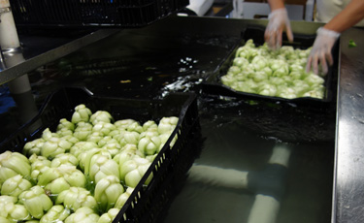
Some crops such as beans and peas, or small-headed crops such as bok choy—as shown here at Harmony Valley Farm—can be “batch-processed” in their harvest trays. Spray wash the cut butts to remove field dirt and make sure the harvest tray isn’t dirty—check the underside—before placing in water tank.
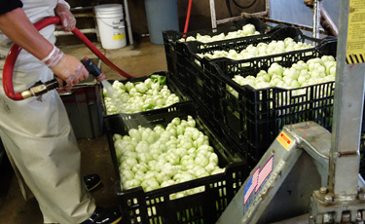
Food Safety:
- Washing produce does not necessarily eliminate pathogens.
- Whenever water comes in contact with produce, the source and quality of the water dictates the potential for contamination. Always be certain to follow food safety practices when cleaning produce.

Internalization Of Pathogens
Immersing fresh produce in water creates a pressure differential that causes water to be pulled into the produce, referred to as imbibing. If there are pathogens present on the produce surface or in the water they can become internalized. Subsequent washing will not reduce pathogen levels once they are inside the produce. It is absolutely crucial to practice good food safety procedures when tank washing.
Food Safety For Tank Washing.
- Water must be potable. (Safe to drink)
- Always use a sanitizing agent in wash tanks.
- Use a test strip to check concentration before adding produce.
- Change water when it becomes dirty.
- Clean tank with detergent between uses, rinse, and then spray with sanitizer.
- Monitor water temperature to prevent internalization of microorganisms.
- Do not overfill tanks. One layer only.
- Do not tank wash produce that is very dirty such as root crops—especially green-top root crops.
- Train yourself and staff on clean hands and equipment procedures.
The 10° F Rule
The difference between the water temperature and the produce temperature is very important. When the water temperature is colder than the produce the amount of imbibing increases.
The concern is greatest for apples, celery, tomatoes, peppers, and potatoes. Fortunately these crops do not need to be tank washed. If tank washing were to be done, the temperature of the wash water should be greater than that of the produce.
When produce with visible dirt or fresh greens—are being washed in a tank, the water should not be more than 10° F colder than the produce.
If you are also using a water tank to hydro-cool and hydro-crisp dirty crops, use multiple tanks to “step-down” the temperature.
Depth and the Internalization Of Pathogens
As produce is pushed deeper in water the pressure differential increases, resulting in higher infiltration. Do not overfill tanks—one layer deep only.
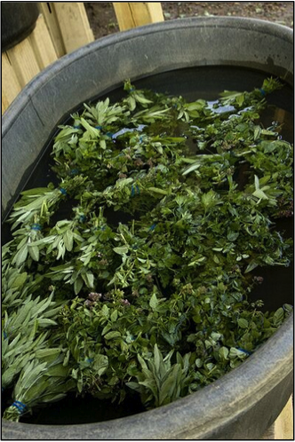
Plastic livestock watering tanks—a common item at farm supply stores—can be used for tank washing and hydro-cooling. They are light and easily moved and cleaned. Here bunched herbs are being cleaned and cooled.
When is tank water dirty?
When sanitizers are exposed to air or organic materials—dirt and plant residue—they dissipate and lose their effectiveness. The best way to check whether a sanitizing solution is still effective is to use a test strip.
Monitor Water and Change It When It Is Dirty.
As wash water becomes dirty, the effectiveness of many antimicrobial agents will decrease. Scooping out organic material does not eliminate pathogens. Change water as needed to insure cleanliness. Using more than one tank can be helpful. When one tank is dirty, work can switch to a second tank while the dirty tank is being drained, cleaned, and refilled. Use a water tank that is deep enough to keep produce away from settling dirt. Plastic livestock watering tanks are lightweight and easy to tip on edge for cleaning. Stainless steel dairy bulk milks tanks provide an easy-to-clean spacious tank that can be upgraded with a Jacuzzi air circulation system.

Baby Greens: spring mix, mesclun, baby spinach and arugula, braising mix
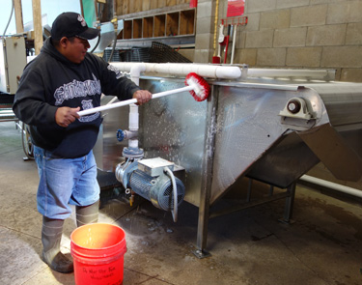
At Harmony Valley Farm, food safety is a high priority. In this photo, pack shed staff is cleaning and sanitizing the equipment before it will be used to clean and cool salad mix. It will be cleaned and sanitized again after use. When asked about GAP audits, Richard de Wilde said, ‘I like the audit process because every year the auditor helps us move to the next level of improvement.” Below, baby greens are inspected on a conveyor belt after being washed. Photo sAtina Diffley
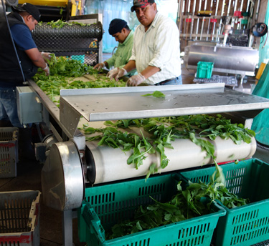
On large farms a wash line with water tanks and a conveyor belt system are used to clean and cool baby greens. Visual inspection removes contaminants such as weeds or bad leaves as the produce moves through the line.
On smaller farms baby greens are generally cleaned and cooled in a double wash system with two tanks of water. The water in the first wash tank should not be more than 10° F colder than the greens. Always use a sanitizing agent and clean water.

A common method for cooling and cleaning baby greens is to line the harvest tote with a nylon or polyester mesh bag. Many farms use 24" by 36" mesh laundry bags that are available at discount stores such as Target costing from $2 to $5. Nylon Net Company sells a 22” X 22” square bag with 1/4” mesh. McDowell Industries sells 32” X 27” knotted McKnit bags.

Once harvested the mesh bag is closed and submerged in a tank of water and gently washed, then moved to a second, cooler tank for a second wash. Using a mesh bag liner helps to protect leaves. Baby greens need to be handled gently; they are fragile and easily bruised.

After washing/cooling the greens are spun dry. Commercial salad spinners are available for purchase. Many farms use a clothes washer that is designated “only-for-greens-drying,” placing several mesh bags in at a time and spinning them in the spin cycle. It also works to spin the bag in the air lasso-style. Be gentle.

Baby greens are then sorted through on a table to pick out any remaining cull leaves, weeds, or other items before packing.
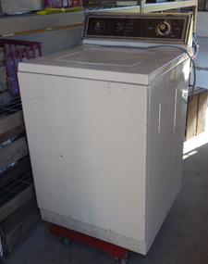This washing machine/salad mix spinner is kept on a wheeled platform for easy moving in and out of the workspace.

Net bags should be washed and rinsed and treated with a sanitizer between uses.

A pack shed staff member at Harmony Valley Farm uses a test strip to check the concentration of Tsunami sanitizer in the “Bubbler.” On the back wall, brushes are color coded for specific use, and knives have a sanitizing water bath ready in front of them with instructions wall-posted on how to use it. On the left, sanitizer and all-purpose cleaner are kept off the floor on a freestanding rack with gloves, goggles, measuring cup, and spray bottles stored close at hand.
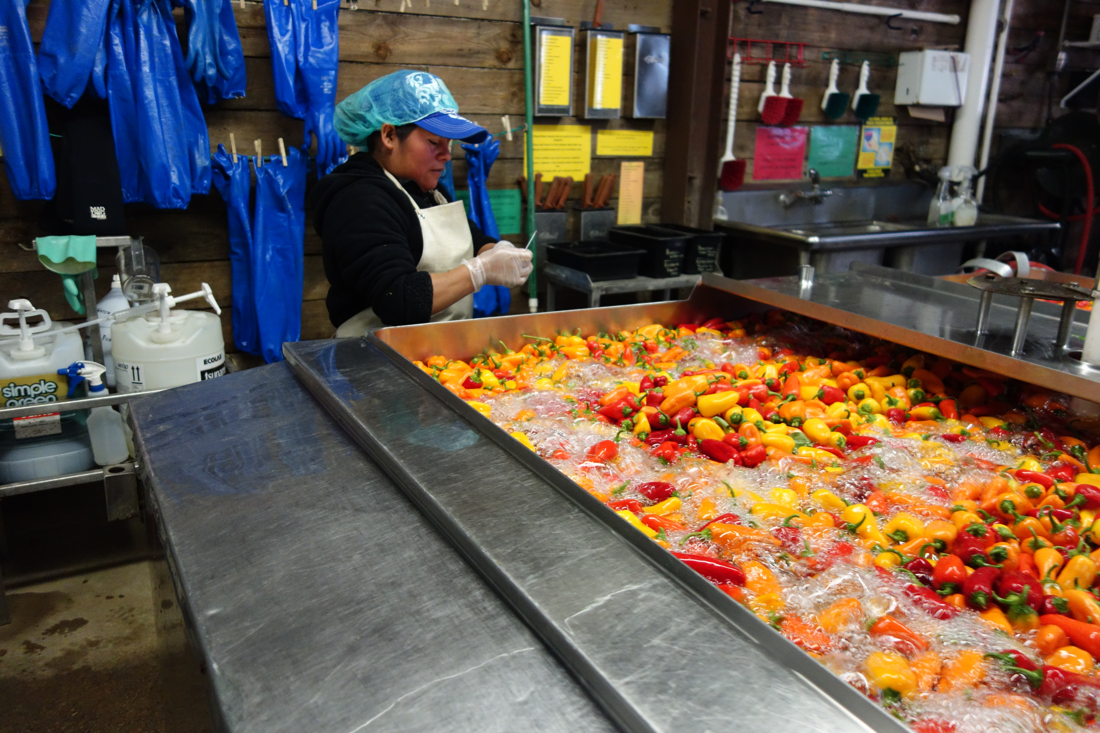

Tank Washing Deluxe—The Bubbler” Jacuzzi Air Circulation System
At Harmony Valley farm, a Jacuzzi water pump moves water through 2 inch PVC to create gentle washing action in the “Bubbler.” Below, workers are using nets to move cleaned peppers into clean totes, and then inspecting for discard peppers. The peppers will next go to the packing room where they will be packed in clamshells and labeled for market.
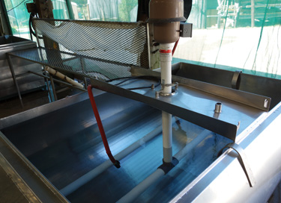
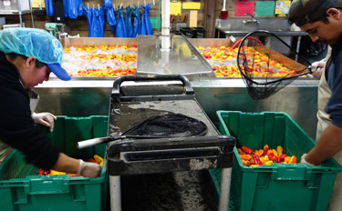
When asked about the “Bubbler,” Richard de Wilde replied, “I saw the technology used in a large commercial salad washer in California back in 1984. I adapted it to what was very available in Wisconsin then, out-of-service, stainless steel bulk milk tanks. Flat bottoms are best; prop up the lower end to make the manifold level. The manifold is made from 2 inch PVC. We use schedule 80 joints, unions and end caps. Schedule 40 breaks too easily. Must be able to take apart for regular cleaning, as dirt and bacteria settle inside and you have a food safety nightmare if you do not clean it. We use the larger Jacuzzi air motor; I think 3 hp rated and size holes and number of holes in manifold to motor size.”

Very Dirty Produce Should Not Be Immersed In A Wash Tank
Bunched roots, bulk roots, or other very dirty produce should not be cleaned in water tanks.
Dirt is a major carrier of food borne illness pathogens. Immersing very dirty produce into a bulk water tank quickly renders sanitizers ineffective, and increases the potential of microorganisms being imbibed into the produce.
Use A Screen Table To Spray Wash, or Drain-Dry Washed Produce
Screen Table/Drainage Rack. Uses: Spray or pressure wash, drain dry, air dry.
Screen tables can be built inexpensively on the farm. If pack shed space is limited, the top only can be built, set up when needed on stacked totes, and then tucked away when out of use.
Drain dry: Before packing, drain-dry tank-washed produce—such as head lettuce or bunched herbs—where water could be held inside causing rot and shortening shelf life. See chart and profiles for crop specifics.
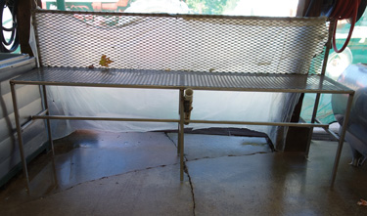
Above, Harmony Valley Farm uses a steel drain table, made on the farm. In the middle photo, Ridgeland Farm used PolyMax floor panels for drain worktables. In the bottom photo, Loon Organic spray washes bulk potatoes on a drain table made with galvanized steel.
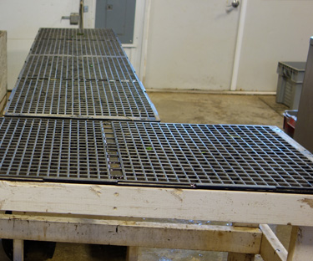
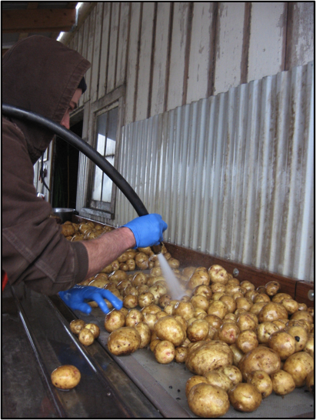

Air dry: Crops such as green beans or peas can be laid on a screen table and gently fluffed to air-dry before packing.
Spray Wash
- Bulk roots can be spray washed on a screen table rolling them with one hand and spraying with the other.
- Bulk roots can be spray washed in a harvest tote with drain holes by spraying while gently rolling produce from side to side.
- A pressure washer can be used to spray wash sturdy crops and bulk roots. Do be careful. Excessive pressure can cut produce and cause bruising.
- Fresh market (uncured) onions, garlic, and shallots, can be spray washed.
Spray Washing Bunched Roots
Special consideration needs to be given to bunched roots. The roots are generally dirty and need to be well washed, and the tops are susceptible to internalization of pathogens and should not be soaked in water until the roots have been cleaned. Sanitizers can be injected directly into spray system water on packing lines or hand held hoses to prevent bacterial and fungal diseases causing spoilage and decay, as well as human pathogenic organisms.
If bunched roots need to be immersed in a water tank to hydro-cool or hydro-crisp, wash them first with a sprayer so that they are clean before they are immersed in water for cooling and crisping.
- Bunched roots should be spray washed.
- Water pressure needs to be gentle on the tops.
- It is OK to use a pressure washer on the roots only.
- After cleaning bunched roots can be put into a tank of water for further cooling and crisping if needed before packing.
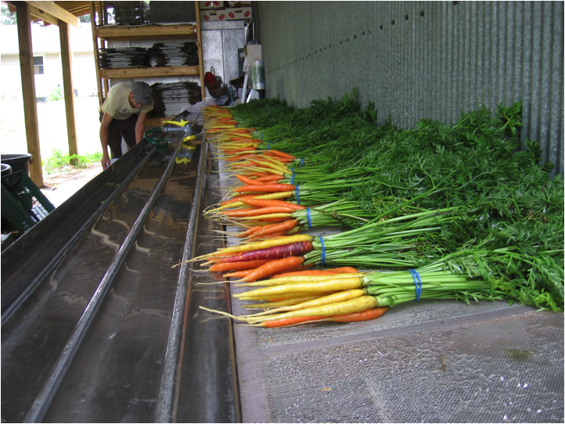 At Loon Organic farm, bunched roots are spray-washed on a screen table. When further cooling is needed they are hydro-cooled in a tank of water after spray washing.

- Do not dry before packing.

Food Safety In The Pack Shed: Cleaning Food Contact Surfaces

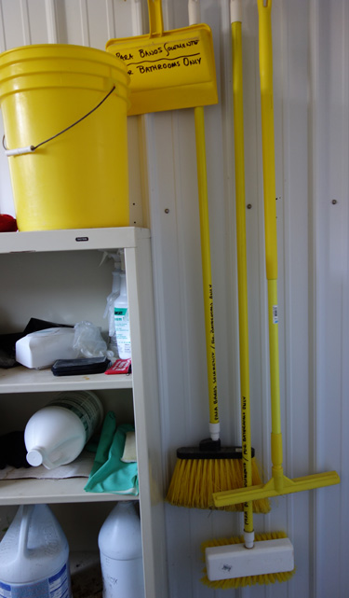
At Harmony Valley farm, designated cleaning tools and supplies are color-coded specific for each task and labeled. Red tools are for cleaning machines, yellow for toilets, and green for tools, tanks, and buckets. Photo Atina Diffley.
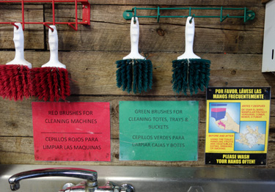

Surfaces that come in contact with produce must be washed, rinsed, and sanitized regularly.
Any surface that comes in contact with produce, either directly or indirectly, is a food contact surface including: field totes and tools, preparation tables, wash tanks, washing equipment, and salad spinners. Food contact surfaces should be smooth and nonporous to allow for effective cleaning. Rough surfaces can harbor dirt and microorganisms.
4-STEPS: Clean, Rinse, Sanitize, Record
- Clean food contact surfaces to remove soil and residue. Wash with soap and potable water. Use a brush or cloth to scrub.
- Rinse with potable water to remove loosened material and soap.
- Sanitize the clean and rinsed food contact surface by spraying with a sanitizing solution. This will kill most microorganisms or reduce them to a non-harmful level. SaniDate is recommend.
- Record each time the procedure is performed. Templates to record are available at http://onfarmfoodsafety.org/
Cleaning and Sanitizing Tips
- Have tools, supplies and waste containers readily available and well labeled as to their designated use.
- Establish a cleaning and sanitizing schedule for equipment and food contact surfaces.
- Delegate cleaning responsibility and provide a detail standard operating procedure. (SOP)
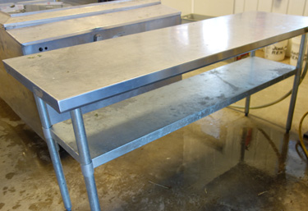
Stainless steel tables are good for pack shed use because they are smooth and easy to clean. Photo Atina Diffley

Mechanical Cleaning and Drying
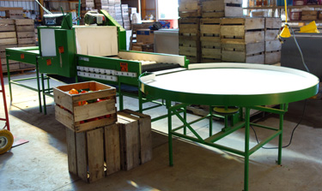
The mechanical wet brush pack line at Grinnell Heritage farm is clean and ready to use.
Tools to mechanize produce cleaning and drying are huge time and labor savors, and even small growers who do many jobs by hand often find they fit into their system and are well worth the investment. Generally round root crops do best in a wet brush pack line, and long root crops in a barrel washer.
Wet Brush Washer with Pack Line: Cucumbers, winter squash, pie pumpkins, ornamental gourds, apples, peaches, peppers, melons, and round root crops such as potatoes, beets, turnips, and winter radishes.
Wet brush pack lines are useful for a large number of different crops and are the most common mechanical washer to be found on small and mid-sized, diverse vegetable farms. Whether your market is wholesale, CSA, farmers market or other, if more than ten bushels of the above produce combined are being cleaned and packed a day, a wet brush pack line can be a valuable and recommended investment. Two to three people can generally wash twenty to thirty bushels per hour. With a large staff, many pack lines are capable of cleaning 100-200 bushels per hour.
Ideal for washing, drying, grading, and packing, a four-piece line includes an in-feed belt, washer, absorber, and round table. Sections can be purchased individually.
- The in-feed belt, while not crucial, is useful for pre-sorting culls and dumping produce to feed into the wash unit. Some farmers choose to not use the in-feed, hand placing the produce directly into the washer.
- Hard or soft brushes can be chosen in the washing unit, depending on the crops cleaned. Additional spray nozzles can be added to increase the amount of water.
- The absorber section has a series of rotating sponge “donuts” that remove excess water to prevent fungal germination and bacterial growth and spoilage.
- The round pack table has an electric motor that turns the table and allows for examination and selection of produce.
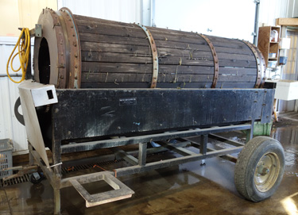
Just finished washing carrots, the barrel washer at Featherstone Fruits and Vegetables is ready for cleaning. Photo Atina Diffley.
- Sizers are available for sorting round crops like tomatoes, potatoes, apples, and peaches based on size. They are an additional unit that is place after the absorber. The hole sizes in the punched belts are made to your specifications.
If soil is hard and produce is not coming through a wet brush pack line clean, pre-spraying can help to loosen dry soil before feeding the produce into the washer. Produce can also be held against the brushes for a short time during loading if additional scrubbing is needed.
Barrel Washer: Carrots, beets, rutabagas, potatoes, parsnips, celeriac, and sunchokes. Turnips and winter radishes can be bruised and are better washed in a brush washer. Generally long roots are best in a barrel washer.
“If more than 500 pounds of roots are washed per day a barrel washer may be a wise investment.” -- Chris Blanchard of Rock Spring Farm, Post Harvest Handling Decision Tool.
Barrel washers are less commonly owned by small and mid-sized vegetable farmers than wet brush washers unless the farms produce quite a few root crops. While there are barrel washers available of many sizes, and built of different materials, the principle is the same; a motor-driven barrel rotates to roll roots through a spray or bath of water. Often a spray bar at the end provides a final rinse before the roots exit the washer.

Barrel washers can be set-up to roll the cleaned roots into a simple box, which are then sorted and packed, or absorbers, convey belts, round tables, or sizers—similar to those in the wet brush pack line photo and description—can be added to create a complete pack line.
Sources for wet brush pack lines and barrel washers.
- Market Farm Implement http://www.marketfarm.com/
- Roeters Farm Equipment http://www.roetersfarmequipment.com

Dry brushing
Tomatoes, eggplant, zucchini, summer squash and melons are usually cleaned by polishing at harvest with a clean glove or cloth. These crops can be washed if needed—though with precautions—and it is recommended that they not be. Peppers and cucumbers sometimes are dry-brushed at harvest though they are generally best cleaned in a wet-brush washer.
Some crops need to be dry-brushed after storage or after curing: Onions, garlic, and shallots.

Curing
Onions, Garlic, Shallots
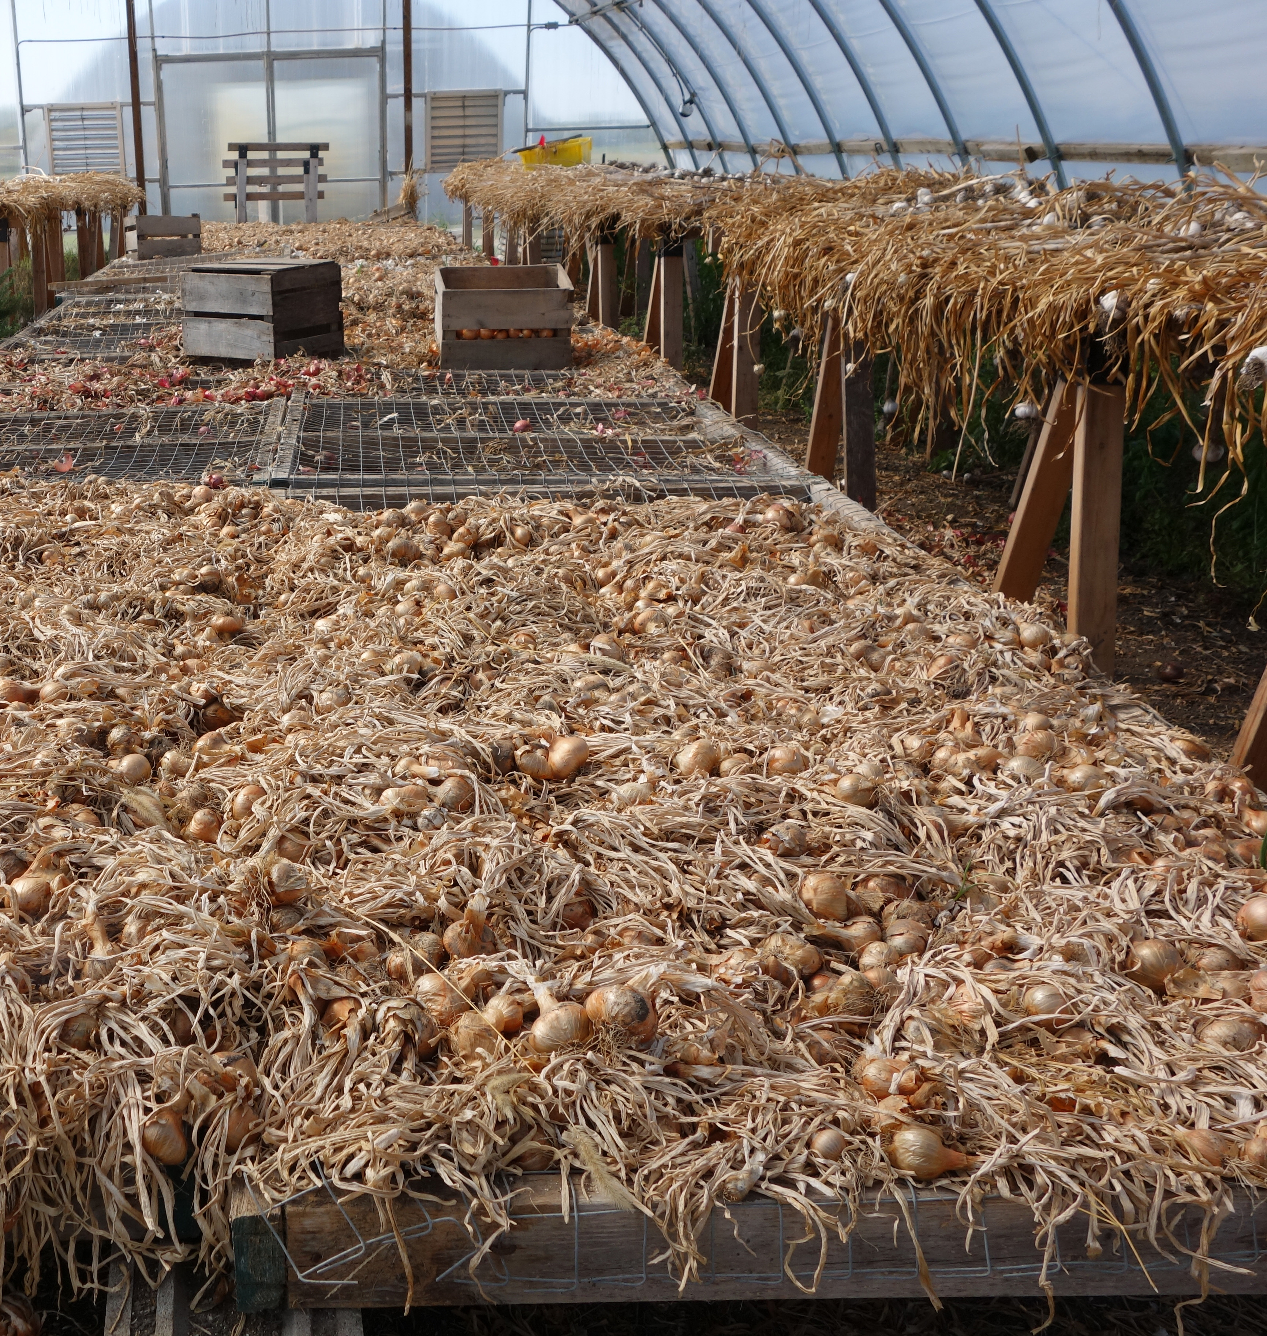
Onions curing on screen benches in the greenhouse at Grinnell Heritage Farm.
If onions, garlic and shallots are sold for fresh market consumption they can be harvested, trimmed, cleaned and packed without curing. For long-term storage, curing after harvest is necessary.
Alliums intended for storage should be harvested after the stalks have flagged and before the top is fully dry. The plant has stopped growing at that point and is beginning to prepare for storage. Spread bulbs out in a single layer, taking care not to bump or bruise them. Garlic and shallots are often bunched while pulling and hung in a shed. Dry greenhouses—with a shade cloth and good airflow—can be a good location for curing. Fans are used to circulate air and promote drying. Heated air can be forced under drying benches with a squirrel cage fan to speed the curing process.
After curing, roots and stems are cut off. Sharp pruners work well. Then the soil and loose skin are removed by rubbing the bulbs between gloved hands. Wearing cotton gloves with vinyl dots can speed the task. Large operations use mechanical roller toppers to speed this task, but they can cause bruising and only very hard varieties should be cleaned in them.

Winter Squash, Pie Pumpkins
Winter squash do not need to be cured before eating. With the exception of acorn squash, which loses quality during curing, it is generally believed that winter squash will keep better if they are curing for 7-10 days of 70° to 80° with good air movement. A greenhouse can be a good place for curing. There is however limited information on the value of a curing period. Likewise there is limited information regarding washing or not before storage. Some farms wash before storage, others store unwashed and clean right before shipping.
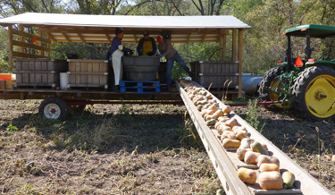
At Harmony Valley Farm, winter squash is washed right in the field in a water tank on a moving wagon as part of the harvest process. Sanitizer is used in the wash water at a higher concentration. After washing, squash is packed in wooden bins and then stored in a dry greenhouse with good airflow.
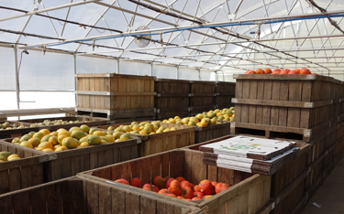
After curing, winter squash and pie pumpkins should be held from 50° to 55° and at 50 to 75 percent humidity. Hubbard squash need more moisture and should ideally be held at 70 to 75% humidity.
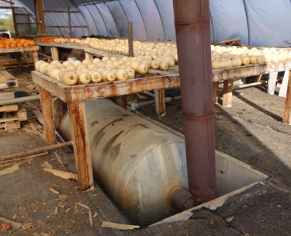
At Small Family CSA Farm, winter squash is cured and stored unwashed on screen tables in a dry and well-ventilated greenhouse. If cold weather threatens the house can be heated with wood.

Sweet Potatoes
Although sweet potatoes can be eaten right away, their flavor and storage quality are greatly improved by curing first at warm temperatures. Cure sweet potatoes by holding for about 10 days at 80° - 85° F and high relative humidity (85—90 percent.) If the temperature is 65° - 75° they should be cured for 2-3 weeks. To maintain the required high humidity, stack storage rates or boxes and cover them with paper or heavy cloth. Or pack in perforated plastic bags. Once they are cured, sore them in a dark location at 55-60°.
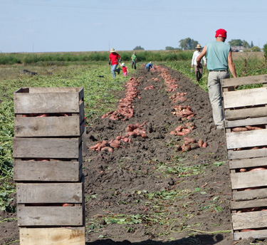
After harvest, sweet potatoes at Grinnell Heritage Farm are cured before marketing.

\

Authors: Atina Diffley, Dennis Fiser, Delia Hollbach, Amanda Korane, Erin Silva

Bibliography: 1 Kitinoja, L. and Gorny, J. 1999. Posthavest Technology for Small-Scale Produce Marketers: Economic Opportunities, Quality and Food Safety. University of California, Davis. 4.5-4.6.
Food and Drug Administration. Draft guidance for tomatoes, leafy greens, and melons 4-1. Guidance for industry: Guide to minimize microbial food safety hazards of tomatoes; Draft Guidance (2009).
Colorado State University Extension. Guide to washing fresh produce.
On-farm Food Safety: Cleaning and Sanitizing Guide (PM1974c,) June 2011, Iowa State University.
, Post Harvest Handling Decision Tool of Iowa Fruit and Vegetable Working Group, Chris Blanchard http://www.leopold.iastate.edu/cool_tools/post_harvest_handling_decision_tool_2

